Major Arcana | KEY 0: THE FOOL | Major Arcana | KEY 2: THE HIGH PRIESTESS
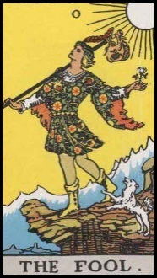 |  | 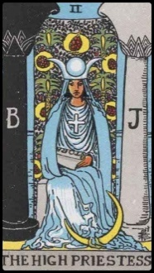
Major Arcana | KEY 1: THE MAGICIAN | Major Arcana | KEY 3: THE EMPRESS
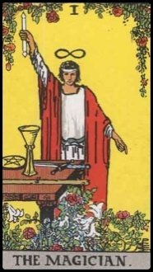 |  | 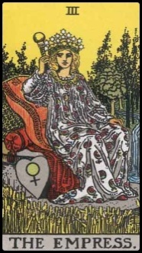

Keyword(s): | Intuition; Sensuality |  |  | Keyword(s): | Innocence; Beginnings
2 – The High Priestess  Spiritual feminine energy with slight sexual overtones. Internal knowledge. Intuition. Tapping into the subconscious. Memory. Duality. Contrast. Caution to keep sensitive information secret for now. Do not tell others yet. Contrast: Key 1, Magician is creation in outer sphere. Key 2, High Priestess is creation in inner sphere; intuitive; psyche.  Reversed Meaning. Deceit. Duplicity. Depending on other cards in spread, could indicate either untapped potential for psychic intuition or sexual attraction or negative use/exploitation of one's psychic intuition or sexual powers. |  |  |  | 0 – The Fool  New beginnings of unbound potential, with a deeper spiritual meaning. Purity in spirit; open-heartedness of a child; innocence and naiveté. Beautiful, creative soul; foolish belief in the accomplishment of impossibly beautiful goals. Eternal youth. Could also mean that a choice is offered, one of great significance. Choice before the Seeker seems minor, but it is a choice that could affect a lifetime, so tread with caution (otherwise might fall off the edge of a cliff).  Reversed Meaning. Seeker has been contemplating a new start or release from the past, but Seeker must be cautious, as this decision may not be the best choice. Could also indicate that Seeker has been acting in reckless disregard of consequences. If in relationship, it is spontaneous. If work related issue, there is uncertainty as to whether it will be hugely successful or a huge failure.
Keyword(s): | Fertility; Nurture |  |  | Keyword(s): | Power; Creation; Mastery
3 – The Empress  Fertility. Fruition. Marriage. Contentment. Material abundance. Wealth. Realization of creative projections. If card appears in a woman's reading, material success will be hers.  Reversed Meaning. Seeker's actions are preventing contentment and fruition. Seeker is the cause of delay in fruition. |  |  |  | 1 – The Magician  Use of power, often creative power, for constructive purposes. Powerful, positive omen. Card appears in spreads for those who are strong in spirituality and character. Individuality. Contrast: Key 0, Fool could potentially be constructive or destructive. Key 1, Magician is constructive and destructive, constructive when upright, destructive when in reverse. Worldly; knowledgeable; self-aware. Self-mastery.  Reversed Meaning. Use of own power for destructive purposes. Could also indicate that the powers of the Magician represent the Seeker's untapped potential.
Major Arcana |  | KEY 4: THE EMPEROR | Major Arcana |  |  | KEY 6: THE LOVERS
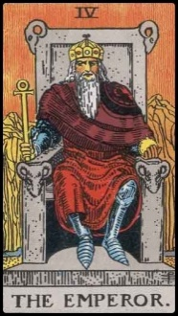 |  |  | 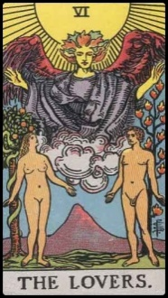
Major Arcana |  | KEY 5 THE HIEROPHANT | Major Arcana |  |  | KEY 7: THE CHARIOT
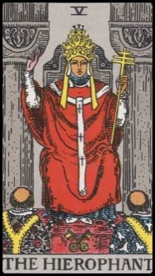 |  |  | 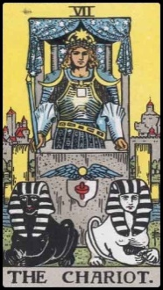

Keyword(s): | Passion; Partnership; Romance; Temptation |  |  | Keyword(s): | Authority; Management
6 – The Lovers  Beginning of romance, but also beginning of temptation. Partnership with just one other person. Also a card about choice: duality or decision to make in a romantic relationship. Choice between vice and virtue.  Reversed Meaning. Interference in a romantic relationship, could be from an in-law, relative, meddling friend, or someone who is jealous of the relationship. Third party is tampering with the romance. Or there is a decision to make in love and there is uncertainty or confusion in a current relationship: Seeker's heart and mind do not align about his or her lover. |  |  |  | 4 – The Emperor  Authority. Government. All is in order, under control. If card appears in a man's reading, indicates self-mastery and virile power. Authority and glory in war and battle. Active force. Father figure. Domination of the mind over the heart. Structure. Regulation.  Reversed Meaning. It is very crucial in Seeker's life right now to be assertive, domineering, and wield authority. Put mind over heart. To solve Seeker's problem, must exercise more assertiveness. Be proactive. Card reversed could also indicate the overthrow of authority or an authoritarian figure in Seeker's life.
Keyword(s): | External Strength; Victory |  |  | Keyword(s): | Tradition
7 – The Chariot  Conquest. Success. Victory. Independence. Triumph over obstacles in Seeker's life. Movement in the right direction. Current movement will lead to victory. Seeker is controlled; master of self-control and self-assertion. Great control over one's own willpower. Equilibrium.  Reversed Meaning. Seeker must reconsider direction. Victory is not certain in current path chosen. Warning to make better choices. The Chariot reversed indicates that Seeker is supposed to enjoy conquest and success, but current choices have put Seeker in the wrong direction. Be careful of movements. Make sure movement is in right direction. Could also indicate lack of use of willpower. |  |  |  | 5 – The Hierophant  Desire to follow conventions and norms. A traditionalist. Seeker of traditional values. Seeker places importance on social and societal approval. Group identification. Perhaps there is bondage to societal conventions. There is an inclination to follow what society deems is "right."  Reversed Meaning. Non-conformity. Seeking freedom and liberation from conformity. Good omen card. Part of the solution for Seeker is to stop going with the conventions of society. Do not try to gain societal approval. What is "right" should be defined and guided by the Seeker only, not others and not society.
Major Arcana |  | KEY 8: STRENGTH | Major Arcana |  |  | KEY 10: WHEEL OF FORTUNE
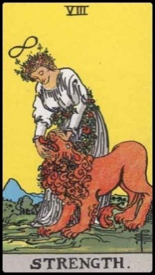 |  |  | 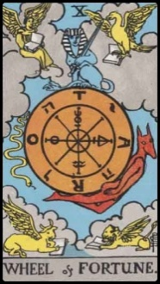
Major Arcana |  | KEY 9: THE HERMIT | Major Arcana |  |  | KEY 11: JUSTICE
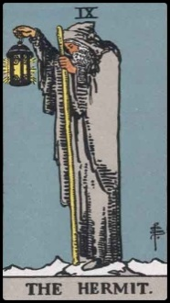 |  |  | 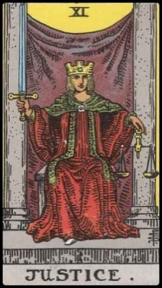

Keyword(s): | Motion; Turning Point; Great External Forces |  |  | Keyword(s): | Inner Strength; Compassion
10 – Wheel of Fortune  Turning point in life. Movement is coming. Forces in motion. Turn of luck. If card appears in the past, Seeker has relied on luck and that is the main cause for how his or her life has turned out. If card appears in the future, then luck is changing for the better soon. If card appears in final card of the spread, then there are very strong external forces beyond Seeker's control that are at play for the situation at hand.  Reversed Meaning. There may be setbacks. Luck has not been on Seeker's side. Change is coming, however. "This, too, shall pass." Currently not the best of luck, but ephemeral: no luck good or bad lasts forever. |  |  |  | 8 - Strength  Triumph of love over hate. Compassion is strength. Triumph of one's higher nature over material desires. Domination over fears. Reminder that Seeker cannot use brute force to exercise will over others. Must use gentle, subtle influence. Contrast: Key 7, The Chariot is another card denoting strength and triumph. However, Key 7 is typically associated with strength to master the world, Seeker’s environment. Key 8, Strength is associated with strength to matter the self. Inner strength an courage.  Reversed Meaning. Seeker must be cautious that brute force is not used. Seeker is using his or her strength in the wrong way. Card is a reminder of what true strength is.
Keyword(s): | Integrity; Fairness; Balance |  |  | Keyword(s): | Introspection; Wisdom; Guidance
11 - Justice  Impartial, fair judgment. Great poise. Decision to be made; decision will be made with integrity. Lawsuits won or disputes resolved in Seeker's favor. If life has seemed unfair to Seeker, it will now balance out. Card may indicate that justice, fairness, and a detached impartiality are critical influences or factors in current situation.  Reversed Meaning. Seeker feels that life is unfair toward him or her, but it is not. The outcome was actually the fair and just outcome, even if it was disappointing to Seeker. Look at karma, the past, at Seeker's own attitudes and actions. If Seeker is honest with him or herself, will see that what has happened is in fact justice. |  |  |  | 9 – The Hermit  Introspection. Wisdom offered. Guidance; mentorship. Someone wiser than Seeker is offering good counsel. That counsel is correct. Seeker should accept the advice. Be open to advice from those who are wiser. Card can also indicate an introvert or solitude.  Reversed Meaning. Seeker was given wise counsel but is not heeding it. Current situation is affected or caused by failure to heed that wise counsel. Foolishness. Immaturity.
Major Arcana |  | KEY 12: THE HANGED MAN | Major Arcana |  |  | KEY 14: TEMPERANCE
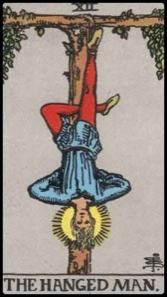 |  |  | 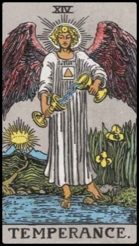
Major Arcana |  | KEY 13: DEATH | Major Arcana |  |  | KEY 15: THE DEVIL
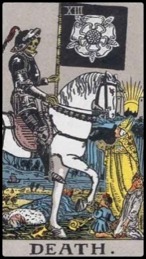 |  |  | 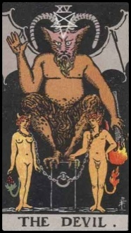

Keyword(s): | Balance; Prudence |  |  | Keyword(s): | Self-Sacrifice
14 – Temperance  Balance. The bringing or fusion of two contrasting elements into harmony. Tempering is an important factor in dealing with Seeker's current situation. Need to reconcile two contrasting elements and bring harmony. Card could indicate that temperance and balance is the key to the matter at hand, or that the Seeker has an innate skill in balancing different forces together.  Reversed Meaning. Temperance is an important factor in the current problem, but Seeker is not applying it. Warning to do a better job tempering and bringing harmony to the contrasting elements currently in Seeker's life. |  |  |  | 12 – The Hanged Man  Self-sacrifice. The mob has metaphorically hung the Seeker because they do not approve of the Seeker's beliefs or what Seeker has done. However, Seeker is right. Seeker must trust self. He or she has wisdom. Enlightenment. The mob's approval is not needed. Tau cross formed by the legs of man pictured on card indicate the balance between dominion and slavery. Note the tau cross in the legs reemerging in Key 21, the World card. May also indicate spiritual growth or an innate ability to prophesy.  Reversed Meaning. Selfishness. Seeker is too self-righteous. Seeker thinks of self as a martyr, but do not confuse martyrdom with selfishness. False idols. False prophet. False spirituality. Preoccupied with appearing holy, but the material and superficial are governing. Could also indicate that Seeker is too preoccupied with material issues; that he or she is neglecting his or her own spiritual development.
Keyword(s): | Bondage; Materialism; Pessimism |  |  | Keyword(s): | Transformation
15 – The Devil  Bondage to the material and superficial. Hopelessness; pessimism. Temptation. Human nature prevails over spirituality. Seeker is subject to evil influences or temptation to not be the most dignified version of him or herself. Seeker must overcome this. Card is a warning that there are negative influences preventing Seeker from attaining goals. Must break free of the bondage. If Seeker is currently in a relationship, it could be an unhealthy one that is chaining him or her down. Card could also indicate perversity. Card suggests there are undesirable personal, internal forces at play. Seeker must work even harder at overcoming the inner demons. Could also indicate addictions, unhealthy relationships, or overdependence on material wealth and material happiness.  Reversed Meaning. Removal of bondage. Will to overcome evil, tempting forces. Card could also indicate that Seeker has a propensity to be tempted, that there may be some weakness in will and character that Seeker must correct. |  |  |  | 13 – Death  Transformation. End of a phase or stage in Seeker's life and the beginning of a new one. The transformation process will be painful. It will be one of the harder moments of Seeker's life, but endure and persevere: a bright new era will be up ahead. "It gets better."  Reversed Meaning. Seeker feels stuck or inert. Inertia. Seeker feels like nothing has been accomplished. Disappointment. Feels that there should be a transition now from a previous stage into a new one, but Seeker is not progressing. There is blockage. Seeker must remove the blockage to transition into the next phase. The transition may be painful. Seeker’s resistance to change is the source of the pain. Card is an indication that Seeker must let go and move on.
Major Arcana |  | KEY 16: THE TOWER | Major Arcana |  |  | KEY 18: THE MOON
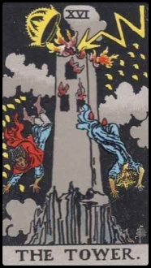 |  |  | 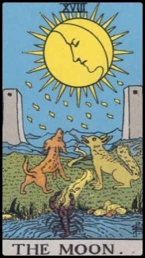
Major Arcana |  | KEY 17: THE STAR | Major Arcana |  |  | KEY 19: THE SUN

Keyword(s): | Duality; Inner Shadow |  |  | Keyword(s): | Hubris; Ego
18 – The Moon  Changes. Duality. Dichotomy. Tame side and wild side. Intuition is strong. Hidden abilities to harness both tame elements and wild elements. There may be secrets. Someone may not be as they appear to be. The Moon represents the shadow of the self, the unconscious mind, repressed weaknesses. It suggests that the accumulated repressions are now causing Seeker’s shadow to surface and have effects on the self-conscious. Facets that have been repressed or latent in Seeker are not emerging and influencing the present and the patent. If card is in the future, unforeseen perils are ahead, and Seeker must use intuition to avoid them. What those perils are will be determined by the other cards in the spread. Card is advising Seeker to maximize use of intuition. Be watchful of deceptive people near you. Go with your gut instinct about people.  Reversed Meaning. Current state of confusion. If Seeker is asking about career, there is uncertainty. If asking about love and relationships, it is a highly volatile and emotional period. There is instability. Risk of misunderstandings in the relationship. If Moon appears in reverse and Seeker is contemplating a risky move, do not take it. Seeker should be as conservative and stable as possible right now. |  |  |  | 16 – The Tower  Downfall as a result of one's own selfish, egotistical ambition. Card may call to mind the Tower of Babel. Seeker ascended to the top full of hubris and through ruthlessness and cunning. However, will be struck down to humility. However, this is good. There will be a lesson in humility. Wisdom will be gained in the end. Seeker is about to learn a hard lesson in humility. Card could also indicate sudden change or destruction of past hard work, but that hard work was the result of hubris and ego. Chance of bankruptcy. Revelation. If the Tower card appears in a reading right side up, it is not a time to take risks. Seeker should be conservative and cautious.  Reversed Meaning. There will still be downfall, but it will be recoverable. Impact will not be as severe on the Seeker. Another interpretation: While upright The Tower suggests false sense of ego and the subsequent jolting back to the “ground reality,” reversed it suggests that Seeker relied on false impressions made by others and as a result, will now feel such a jolt. However, not attributed to Seeker’s own ego, but rather based on Seeker’s reliance on misrepresentations others have told the Seeker. May also indicate that Seeker has been falsely accused of something.
Keyword(s): | Success; Attainment |  |  | Keyword(s): | Hope; Inspiration
19 – The Sun  Success. Attainment. Accomplishment. Liberation. Good marriage. Achievement in the arts or sciences or in Seeker's profession. Look at cards in spread to determine what kind of success. If the card follows a bad omen, then those negative forces will clear. Card could also indicate mastery of the ego. Glory. Salvation.  Reversed Meaning. There may be loss of something valuable to Seeker. Be careful. There may be some marriage troubles. Achievements in Seeker's profession will be delayed. Freedom and success will be obfuscated. To determine what forces will obfuscate, look at surrounding cards in spread. Could also indicate untapped potential for incredible glory and accomplishment. There may be setbacks causing Seeker to lose in enthusiasm. Card is a caution that Seeker must regain momentum, energy, and restore that enthusiasm to see this project through to success. |  |  |  | 17 – The Star  Hope. Inspiration. Good health. Abundance of health, happiness, harmony, beauty, hope, or peace in Seeker's life. (Note: Card does not foretell material abundance.) The abundance here is more spiritual. Contentment. Good omen. Bright, hopeful future ahead. The Star suggests renewal or restoration of hope.  Reversed Meaning. Seeker's outlook is too pessimistic. Negativity may have adverse effect on Seeker's health. Need to be more hopeful of the future. Negative outlook is part of Seeker's current problem. Seeker must turn that pessimism around to optimism. Seek inspiration in the world around you. Be hopeful. Seeker's lack of optimism is part of Seeker's problem.
Major Arcana |  | KEY 20: JUDGEMENT | Major Arcana |  |  | KEY 21: THE WORLD
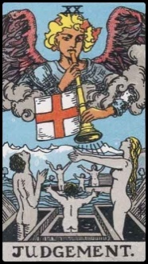 |  |  | 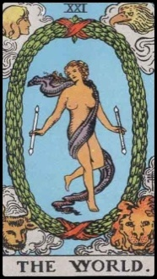
Minor Arcana |  | ACE OF WANDS | Minor Arcana |  |  | TWO OF WANDS
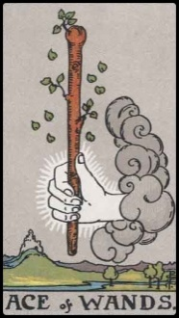 |  |  | 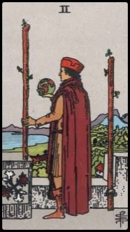

Keyword(s): | Fulfillment; Completion |  |  | Keyword(s): | Awakening; Epiphany; Renewal
21 – The World  Fulfillment. Completion. Triumph in all undertakings. Best card in the deck. Reward. Great things to happen to the Seeker. Final state of cosmic consciousness, supreme good/balance. Command of growth energy, emotions, ambitious, and material goals. All will work out. Synthesis. If card appears in the Seeker's past, then Seeker has potential for great triumph and cosmic consciousness. Could indicate Seeker's importance in the greater cosmic landscape. If card appears in Seeker's present, indicates contentment. If card appears in Seeker's future, predicts great success and glory to come. Something of great significance will happen to Seeker.  Reversed Meaning. Triumph and supreme greatness will come, but is delayed. To ensure that it comes, Seeker must tread carefully and make the correct decisions going forward. To determine what the correct decisions are, look to the other cards in the spread. Could also indicate that there was a major change presented in Seeker's life that could have been great for Seeker's future, but Seeker is afraid of change and is hesitating to take the necessary actions. The World appearing reversed in a spread could also indicate that Seeker is consciously and knowingly in denial. Seeker is denying the truth or significance of what is going on in his or her life and instead is remaining willfully ignorant. |  |  |  | 20 - Judgement  Spiritual awakening. Epiphany. Renewal. Change in personal consciousness. Realization. An important life lesson will be learned. Events currently going on in Seeker's life will be the catalyst to a personal awakening. All evidence has been made available to Seeker and Seeker has made a judgment. Upright, this card indicates that the judgment is correct and will bring an awakening or epiphany in Seeker.  Reversed Meaning. Seeker has made the wrong judgment or opinion about something significant. Seeker misinterpreted the facts or evidence presented and has arrived at the wrong conclusion. Could also indicate an observation from the cards that Seeker is not interested in the spiritual life. Seeker must give more focus to developing his or her spirituality. Spirituality is not a main concern in Seeker's life right now, but should be.
Keyword(s): | Accomplishment (Personal Development; Career) |  |  | Keyword(s): | New Venture (Personal Development; Career)
Two of Wands  Artistic or scientific success. Professional success. Balance or gain in work/career. Two of Wands could also indicate big ambitions and that Seeker has accomplished much (or possibly inherited much) but still wants more—Seeker wants the world. Calls to mind Alexander the Great. Early stages of an enterprise are going to be fruitful, though there may be a period of waiting. Card could also indicate a worldly, aristocratic, educated individual with great creative ability for the advancements of arts and science. [Compare with Three of Wands, which indicates business or commercial success. Two of Wands indicates innovative, artistic, or scientific success.]  Reversed Meaning. Early stages of an enterprise seem to have started off well, but may not reach fruition as Seeker anticipated. This is attributed directly to hasty planning on Seeker’s part. Be more patient. Do not rush things. Watch the details for this project, especially. Card warns Seeker to not be impatient. Card in reverse could also indicate that others may usurp the fruits of Seeker's labor. |  |  |  | Ace of Wands  New venture or enterprise. Material and spiritual progress coming to Seeker. Start of a new journey. Possible inheritance or new career. Card could also indicate a birth in the family. Child will be energetic and motivated.  Reversed Meaning. Setbacks to a new enterprise. May have hard time completing goals. Cards reminding Seeker to stay focused and persistent. Channel more determination to see the venture through to finish. Greater will needs to be exercised to overcome the setbacks.
Minor Arcana |  | THREE OF WANDS | Minor Arcana |  |  | FIVE OF WANDS
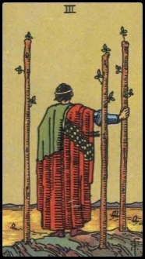 |  |  | 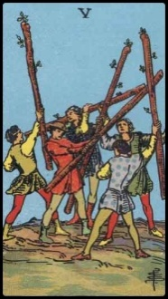
Minor Arcana |  | FOUR OF WANDS | Minor Arcana |  |  | SIX OF WANDS
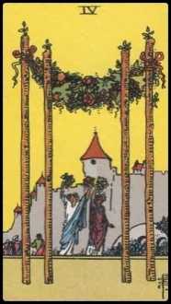 |  |  | 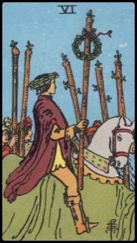

Keyword(s): | Competition; Envy from Others |  |  | Keyword(s): | Attainment; Commercial Success
Five of Wands  Competition in Seeker's field of activity. Be cautious of those around you. Are they truly your friends? Or are they competitors? Others may envy what you have, which leads to quarrels.  Reversed Meaning. Harmony in Seeker's field of activity. New opportunities. You have proven yourself in your field and you have beat out your competition. |  |  |  | Three of Wands  Business or commercial success. Success after hard work or hardship. Thus, the fruition Seeker will now enjoy is well deserved. Seeker will feel validated. [ Compare with Two of Wands, which indicates arts or sciences success. ] Could also indicate that help is coming.  Reversed Meaning. Mistake made through carelessness. Card in reversed is warning not to overlook details. Doing so may cause failure of entire project. Commercial or business project will have setbacks and disappointments. Despite a lot of effort, may not come out as planned.
Keyword(s): | Victory; Good News; Advancement in Career |  |  | Keyword(s): | Prosperity; Harvest; Domestic Bliss; Marriage
Six of Wands  Victory. Good news. Advancement and progress in work/career, profession, or innovation, arts and sciences. Leading others to victory. Glory.  Reversed Meaning. Positive omen. However, there are current delays and challenges in Seeker's way, but victory and success will come, just delayed. Could also indicate strong untapped potential in Seeker for advancement in arts and sciences, work/career. |  |  |  | Four of Wands  Harvest. Hearth. Prosperity and peace in the domestic sphere. If Seeker is in a romantic relationship, it may end in marriage. Productivity. Card also suggests happiness within one’s community. Celebration. May also indicate work/career success accomplished through teamwork.  Reversed Meaning. Still a good card in reverse. Seeker will experience productivity and happiness, but to a lesser degree or it will not have as significant an influence on the psyche or consciousness of Seeker. Card in reverse could also indicate that Seeker already possesses prosperity, peace, and happiness, but fails to appreciate what he or she has and does not seek his or her own fortune. It could also indicate neglect of the domestic sphere and compromising home and hearth for work/career.
Minor Arcana |  | SEVEN OF WANDS | Minor Arcana |  |  | NINE OF WANDS
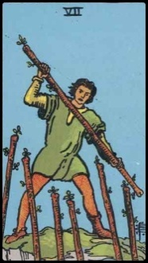 |  |  | 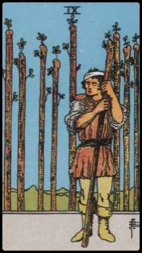
Minor Arcana |  | EIGHT OF WANDS | Minor Arcana |  |  | TEN OF WANDS
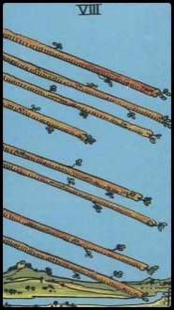 |  |  | 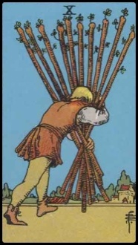

Keyword(s): | Self-Defense; Protective |  |  | Keyword(s): | Resistance; Defiance
Nine of Wands  Seeker feels in a defensive, protective mode. Feels like he or she has to fight to defend own. Exhausted from all the fighting. Seeker is up in arms, prepared for battle. Seeker is a fiercely independent spirit, mentally active, daring. Seeker is full of energy and fire. However, cards urge that there is another way. Seeker does not need to be so defensive and overprotective.  Reversed Meaning. Seeker feels like he or she is battling against the world to defend what belongs to him or her, and is exhausted from that fight. At the brink of giving up. Seeker is losing energy and losing his or her inner fire. Card indicates the result of what happens if a Seeker has not heeded the warning of the card upright: Seeker is now exhausted from the fighting. Must seek another way to reconcile. |  |  |  | Seven of Wands  Strong will. Defiance. Resistance. Seeker is fierce and fearless. Ability to hold and stand own ground against multiple adversaries. Stiff competition in business. Courageous character. If card is in the past position, then Seeker has already won the fight. If in present, a lot of fighting and defiance in current situation. If in future, will need to show great resistance soon.  Reversed Meaning. Strike now. Indecision plagues the Seeker. Need to have more confidence in own strength. Seeker has the ability to fend off his or her adversaries, but has not been doing so to the fullest potential. Do not wait for a "perfect moment." You need to strike now.
Keyword(s): | Burdened; Unable to see one's own path in life |  |  | Keyword(s): | Action; Incoming Message; Buzz; New Ideas
Ten of Wands  Seeker is carrying an oppressive load and while Seeker is handling it well, the load is hindering him or her from seeing the path. Seeker cannot see where he or she is going right now as a result of the oppressive load. Maybe Seeker is indecisive about the path he or she should take in life because Seeker is doing way too much at once right now. The load carried is preventing sight and insight into the future.  Reversed Meaning. Too big a burden. Seeker is losing a grip on the load. Seeker bears more than he or she can handle right now. Must prioritize. Resolution of matter at hand rests with Seeker alleviating his or her burden. |  |  |  | Eight of Wands  Progressive action. Seeker is fast approaching his or her goals. Action card. A great deal of buzz and activity to come. New ideas will be highly promising. Card could also indicate the arrows of love fast approaching. Card could also indicate that a message or communication is coming soon that will bring good news.  Reversed Meaning. Inaction or altercation that prevents progressive action. The message or communication that is coming will bring bad news. Quarrels or conflicts ensue due to rash actions. Be more cautious. Card in reverse could also be a warning that someone in Seeker's life is extremely jealous of him or her and Seeker must be careful not to let that person's jealousy harm Seeker. Card may also indicate that Seeker is acting too hastily or rashly; take it slower.
Minor Arcana |  | PAGE OF WANDS | Minor Arcana |  |  | QUEEN OF WANDS
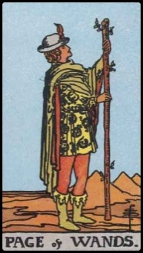 |  |  | 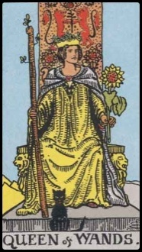
Minor Arcana |  | KNIGHT OF WANDS | Minor Arcana |  |  | KING OF WANDS
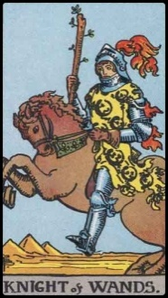 |  |  | 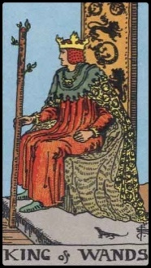

Keyword(s): | Self-Assured; Nature Lover; Virtuous |  |  | Keyword(s): | Motivated; Creative; Adventurous
Queen of Wands  Energetic, self-assured, attractive woman. Mature woman with the power of attraction. Lover of nature. Great keeper of the home and hearth. Well-liked and honorable. Strong-willed and virtuous. Has sound judgment. Unlike the Page of Wands, who is a bright burst of creative energy that has not yet been harnessed, the Queen of Wands can control and channel her creative energies to yield results.  Reversed Meaning. Capitulation. Indicates a yielding disposition. Seeker is yielding to others. Non-confrontational. Card could also indicate acting without honor or virtue. Card could suggest an older, motherly, nurturing figure in Seeker's life with whom Seeker argues with a lot. Quarrels with this mother figure is having an adverse impact on the situation at hand. |  |  |  | Page of Wands  Creative, enthusiastic, confident energy, with a lot of youth. Exploration. Adventurous. Card may indicate adventurous new beginnings. Perhaps someone in Seeker's life who is a young female or very young child. Warm, ambitious, passionate, a high achiever, dynamic personality. However, also too young in mind. Much growing up needed. In a reading for a young male Seeker asking about love, could indicate the appearance of a young woman with the foregoing qualities.  Reversed Meaning. Lacking creativity or innovation. Cowardice. Passivity. Fear of exploring the unknown is what holds Seeker back. May indicate insecurity in Seeker. If Seeker is a young female, this card in reverse could indicate a peer who is insecure with herself and as a result, is taking it out on the Seeker and causing a negative impact on Seeker's current situation. If Seeker is a young male, could indicate a girlfriend, significant other, or female friend with such an impact.
Keyword(s): | Authoritarian; Fiery Temper |  |  | Keyword(s): | Impetuous; Thrives on Challenge; Hasty
King of Wands  Creative male energy. A man who probably thinks he is always right. A man of strong will. Fiery male energy with authority. Man is most likely married or head of his household. Handsome, passionate, noble, strong, but hasty and quick to temper, quick to judgment. Professional man with executive powers.  Reversed Meaning. Patronizing male authoritarian figure. Tyranny. Could indicate an authoritative male figure in Seeker's life who Seeker often quarrels with. Could indicate a negative, conflicting, or tense relationship between the two. |  |  |  | Knight of Wands  Fiery impetuous character. Likes to stir conflict. Thrives on challenge. Easy for this character to get into fights. Hasty. Competitive. However, this character has a lot of potential to become great someday. Must control immaturity. In a reading for a young female Seeker asking about love, could indicate the appearance of a young man with the foregoing qualities.  Reversed Meaning. Insecurity. Dragging feet on an important decision. Hesitating in a daunting or risky project. Look to other cards in spread to see whether hesitation is warranted or whether Seeker needs to be more assertive. If card appears in reverse for a young female Seeker, may indicate negative influence in Seeker's life from a young man with such qualities.
Minor Arcana |  | ACE OF CUPS | Minor Arcana |  |  | THREE OF CUPS
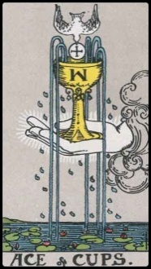 |  |  | 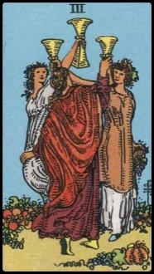
Minor Arcana |  | TWO OF CUPS | Minor Arcana |  |  | FOUR OF CUPS
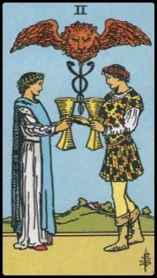 |  |  | 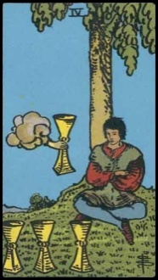

Keyword(s): | Celebration; Social Events; Rejoicing |  |  | Keyword(s): | Abundance; Beginning of Love or Good Health; Breakthrough
Three of Cups  Good fortune and good company. Social events. Time for rejoicing. Happy conclusion in an undertaking that took team effort. Community. Friendship. Camaraderie.  Reversed Meaning. Seeker is spending more time on play than work. Card is warning Seeker that too much pleasure could become pain. Seeker relies too much on pleasure seeking. Seeker’s fullest talents remain dormant and are not being utilized. Card could also indicate that Seeker thinks all has gone well and has rejoiced prematurely. Be careful. There is more to the story and not necessarily happy news. Card could also indicate Seeker is sexually unhappy. |  |  |  | Ace of Cups  Beginning of prosperity. Overflowing of love, joy, beauty, or health. A breakthrough of some kind. Abundance in prosperity. Productivity. Fulfillment of emotional desires. Fortune in love and marriage. Much happiness and peace found in new relationship. If Seeker is asking about romance, this card indicates that a prosperous, joyous, healthy love is coming.  Reversed Meaning. Rejecting matters of the heart. Seeker is pushing away happiness and joy. Perhaps perception of love is too materialistic. Seeker needs a spiritual breakthrough. Could be a warning that Seeker’s objectives are too superficial or materialistic and won’t bring joy. Card could also mean there is promiscuity in a relationship, unstable desires, overindulgence. Trouble in love.
Keyword(s): | Introspection; Personal Reflection |  |  | Keyword(s): | Friendship; New Romance; Cooperation
Four of Cups  Time for personal reevaluation and internal reflection. Seeker is not interested in material gain or success right now. Instead, Seeker is trying to understand the self. Seeker needs to understand his or her own spirituality. This card is advice to the Seeker to close off from the outside world and devote more time to introspection.  Reversed Meaning. It is now a good time for a new relationship. Seeker is ready to face the world again. Seeker had previously closed him or herself off from the world for introspection, but now it is time to come out of that shell. Seeker is ready for new goals and more accomplishments. |  |  |  | Two of Cups  Relationship of healing. New romance. The romance will have a strong friendship element to the love. Well-balanced. Harmony. Cooperation. Two compatible personalities. Two individuals who work well together.  Reversed Meaning. Loss of balance in relationship. Misunderstandings with one that the Seeker regards highly. If married, there is tension in marriage due to in-laws.
Minor Arcana |  | FIVE OF CUPS | Minor Arcana |  |  | SEVEN OF CUPS
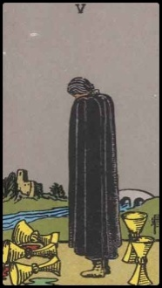 |  |  | 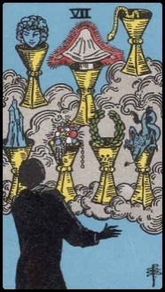
Minor Arcana |  | SIX OF CUPS | Minor Arcana |  |  | EIGHT OF CUPS
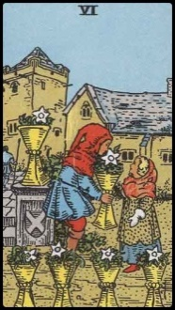 |  |  | 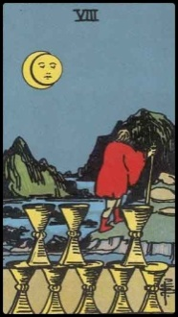

Keyword(s): | Indecision; Confusion; Obfuscation |  |  | Keyword(s): | Loss of Something Cherished; Mourning
Seven of Cups  Inability to choose from many appealing options, but the appeal is superficial. Too much going on at once in Seeker’s life. Vision is clouded and Seeker is obstructed from seeing what he really wants as a result of the tempting options. The options before Seeker as indicated by this card are superficial (i.e., wealth, fame, sex, etc.)  Reversed Meaning. Reversed card is good omen. It indicates that Seeker has made or will make (depending on where the card is positioned in the spread) a decision among many appealing but superficial and tempting options and Seeker has chosen or will choose correctly. The cards affirm that Seeker is moving in the right direction. |  |  |  | Five of Cups  Sorrow. Mourning. Loss of a loved one or loss of something Seeker loved or held dear; emotional losses in relationships. However, while mourning Seeker’s loss, Seeker neglects to see what he or she still has. Note how two of the cups in the card are still intact, but cloaked man in the image cannot see them. If in a relationship that is on the verge of ending, Seeker is asked by the cards to reexamine the issue and see if repairs or amends can be made. Look to see what you have and cherish it. Seekers feels a loss of a particular future path. A relationship that should have lasted forever has now ended. Something that was meant to be now shall never come to pass.  Reversed Meaning. Return and restoration of hope after recent losses. The situation is just beginning to turn up for the Seeker. Seeker is forming new alliances. Seeker is just starting to summon up the courage to deal with the loss.
Keyword(s): | Abandonment; Soul-Searching Journey |  |  | Keyword(s): | Childhood; Nostalgia; Memories of Past
Eight of Cups  Abandonment of past fruits. Seeker is leaving behind something he or she spent much effort and care on nurturing or developing. However, Seeker is leaving it behind on his or her own terms, at will. Seeker is looking for more than material success. Search for a higher meaning. May also indicate a charitable, beautiful, or kind personality. Seeker is on a spiritual journey.  Reversed Meaning. Seeker has returned to feasting and festivities, enjoying in earthly, material pleasures. Seeker has abandoned the spiritual path for the material. Or the card could indicate peripatetic tendencies in the Seeker. Look to the cards surrounding this card in the spread to determine the appropriate interpretation. |  |  |  | Six of Cups  Nostalgia. Childhood or the past is still a factor in current life, but it is a positive factor. Something positive from Seeker’s past will soon visit the present. If asking about a problem, the card indicates that the root cause can be found in Seeker’s childhood. If card is in the future, look to neighboring cards: it may indicate the new start of a family or additions to the family.  Reversed Meaning. Childhood or the past is still a factor in current life, but it is a negative factor. Something negative from Seeker’s past will visit the present. Clinging onto the past and nostalgia, unable to progress forward. Could also indicate fertility issues in older women or difficulties with disciplining children.
Minor Arcana |  | NINE OF CUPS | Minor Arcana |  |  | PAGE OF CUPS
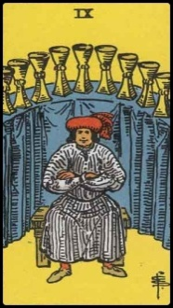 |  |  | 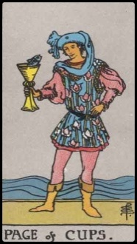
Minor Arcana |  | TEN OF CUPS | Minor Arcana |  |  | KNIGHT OF CUPS
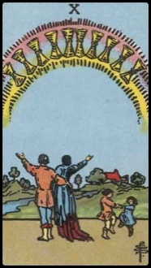 |  |  | 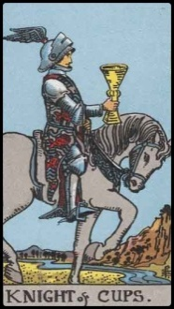

Keyword(s): | Dreamer; Unrealistic Expectations; Quixotic |  |  | Keyword(s): | "The Wish Card" - Success; Material Fulfillment
Page of Cups  Gentle young female who is loving, intuitive, and embraces her emotions. She is likely artistic or interested in the arts. A dreamer. Sweet-natured. Full of imagination. Warm, pacifist, balanced personality. In a reading for a young male Seeker asking about love, could indicate the appearance of a young woman with the foregoing qualities.  Reversed Meaning. Unrealistic expectations. Quixotic. Impractical visionary. Impulsive. Emotional instability. Indolence. Could also indicate a young woman in Seeker's life who embodies the qualities of the Page of Cups, but who has a negative impact or influence on Seeker's current situation. |  |  |  | Nine of Cups  The wish card. Material success is assured. Seeker will get his or her wish. Everything will work out well for Seeker. Fondness of luxury and comfort; Seeker attains luxury and comfort. Desires fulfilled. Contrast: The Ten of Cups suggest spiritual prosperity; wealth in relationships and love.  Reversed Meaning. Seeker’s wish will not be fulfilled. Look to the surrounding cards in a spread to see why. Could also indicate too much self praise and conceit. Seeker thinks too highly of him or herself. Vanity. However, it is because Seeker is highly talented and skilled at attaining luxury and comfort. Exceptional ability at gratifying him or herself.
Keyword(s): | Charming; Great People Skills; Sensitive |  |  | Keyword(s): | Ultimate Happiness; Emotional Fulfillment
Knight of Cups  A charming young man of high intelligence. Great people skills. Romantic. Sensitive. Dreamer. Skilled in the arts. Social. Charismatic. In a reading for a young female Seeker asking about love, could indicate the appearance of a young man with the foregoing qualities.  Reversed Meaning. Feelings of discouragement. Could also indicate someone who is out of touch with reality. Overly emotional. Withdrawn from the world. Laziness. Could also indicate a young woman in Seeker's life who embodies the qualities of the Knight of Cups, but who has a negative impact or influence on Seeker's current situation. |  |  |  | Ten of Cups  Ultimate happiness. Happy family life. True friendships. Rewarding relationships. Not necessarily indication of wealth or material prosperity, but a strong indication of genuine joy and love. Contrast: The Nine of Cups suggests that the success is material; gain in wealth.  Reversed Meaning. Discord in the domestic sphere. Quarrels within the family. However, if all the cards surrounding this one in a spread are powerfully positive, then this could indicate that happiness is to come, but there may be a delay. A third possible meaning for this card is a warning: Seeker is trying too hard to mold life into a “perfect” life according to certain standards. Be content with the joys and the relationships in your life already, even if they do not conform to certain societal standards or expectations of the “perfect” life.
Minor Arcana |  | QUEEN OF CUPS | Minor Arcana |  |  | KING OF CUPS
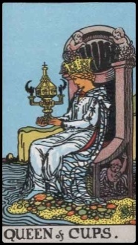 |  |  | 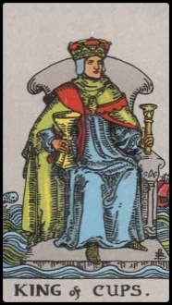
Minor Arcana |  | ACE OF SWORDS | Minor Arcana |  |  | TWO OF SWORDS
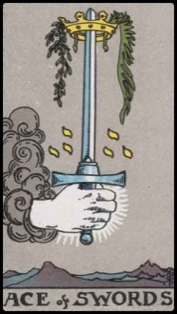 |  |  | 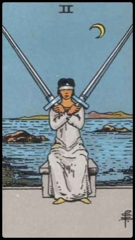

Keyword(s): | Nurturing; Tender; Poetic; Well-Loved |  |  | Keyword(s): | Diplomatic; Caring; High Stress
Queen of Cups  A loving mature woman. Tender. Nurturing. This woman is a counselor. She is a nurturer. Emotional. A good wife and/or a good mother. Poetic. Kind. She is well-loved by many.  Reversed Meaning. Warning that woman who appears to be tender and warm is in fact manipulative. Deceit from a close friend or someone Seeker trusts. |  |  |  | King of Cups  Wise and diplomatic mature man. Caring male energy. However, may be a man with a troubled conscience or a lot of stress and pressure in his life. Yet his life is good overall, fruitful, and full of blessings. He deals with his stress well. Quiet, calm temper. Could be a professional man in law or business; very strong skills in the arts and letters. May think too much.  Reversed Meaning. Too emotional. Being spiteful to someone who cross you due to being overly emotional. Agitation. Too quick to temper.
Keyword(s): | Conquest; Valiant; Potential Good Leader |  |  | Keyword(s): | Stalemate; Difficult Choice; Indecision
Ace of Swords  New conquest. Beginning of a conquest or victory. Could also indicate the birth of a child who will be valiant, ambitious, a leader. Champion. Potential to achieve great power. Card frequently appears in spreads for Seekers with the potential to become great leaders, but who has not yet become one.  Reversed Meaning. Seeker has the potential to be valiant and victorious, but certain decisions Seeker has made or will make (depending on whether card appears in the past, present, or future) are more destructive than constructive. Seeker is cautioned to exercise wisdom when wielding power, or else victory will be short-lived, if there is any at all. |  |  |  | Two of Swords  Difficult choice. Stalemate. Seeker is having a difficult time seeking his or her current situation. Seeker feels blinded, grasping through the darkness and unknown. There is a stalemate in the current situation. Indecision. Possible trouble ahead due to the indecision. Seeker is a strong-willed individual, someone who is capable of carrying large burdens (the way the woman depicted in the card effortlessly and dauntlessly holds both large swords). Choosing between two bad options. Contrast: Seven of Cups is about choosing between a variety of superficially appealing options. Two of Swords is about two bad options.  Reversed Meaning. There was a stalemate but Seeker seems to have made up his or her mind already. However, card cautions of trouble and hardship ahead. Chance that Seeker’s movement is in the wrong direction. Think twice.
Minor Arcana |  | THREE OF SWORDS | Minor Arcana |  |  | FIVE OF SWORDS
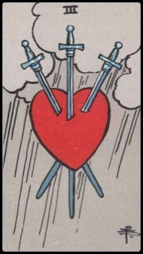 |  |  | 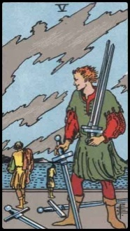
Minor Arcana |  | FOUR OF SWORDS | Minor Arcana |  |  | SIX OF SWORDS
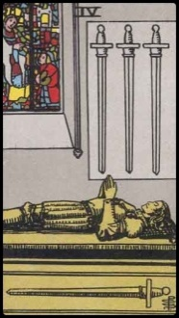 |  |  | 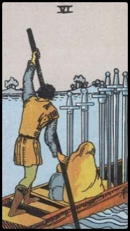

Keyword(s): | Corruption; Spitefulness; Getting an Advantage |  |  | Keyword(s): | Strife; Quarrels; Storm of Emotions
Five of Swords  Spitefulness. Seeker has been taking advantage of others to get ahead. Victory feels empty. Seeker thinks he or she has won, but the storm is just coming. Could also indicate that the competition or battle is now over and Seeker has won, but at what cost? Seeker may have lost his or her friends and allies over the situation. This card is about gaining unfair advantages.  Reversed Meaning. Seeker will have an opportunity to take advantage of others for personal gain, but it is not clear whether Seeker will take it. Cards warn that doing so will result in ultimate loss and defeat. Victory by unethical gains is short-lived. |  |  |  | Three of Swords  Strife. Turmoil. Loss. Sorrow. Storm of emotions. Storm of the heart. There have been deep misunderstandings in the situation at hand and as a result, storm is coming. Political strife. Conflicts as a result of ambitions and aggressions. Quarrels with loved ones over politics, ideologies, power imbalances, or aggression.  Reversed Meaning. Loss. Disorder. However, the loss and disorder is not as intense as it would be if the card was right side up. Nearby cards in spread will indicate what kind of loss has occurred. Card reversed indicates loss and sorrow to a lesser degree.
Keyword(s): | Journey; Passage away from Past Sorrow |  |  | Keyword(s): | Repose; Time for Rest After Illness or Battle
Six of Swords  Journey. Passage away from hardship or sorrow. Change for the better. Good time to get away. Travel. Rough waters will soon be behind you. The horizon is smooth and calm. Cutting one's losses and moving on.  Reversed Meaning. Planned journey postponed. Delays in travel. No immediate way out of a hardship. Carrying heavy emotional baggage into a new phase. Afflicted. |  |  |  | Four of Swords  Time for rest after war, strife, or battle. It is a time for reclusion and retreat. Seeker may have been sick or recluse, inactive. Right now is a recovery period for Seeker.  Reversed Meaning. Time of reclusion is over. Cards suggest that Seeker go back out into the world to experience it. Rest time is over. Nevertheless, cards still warn of social unrest up ahead.
Minor Arcana |  | SEVEN OF SWORDS | Minor Arcana |  |  | NINE OF SWORDS
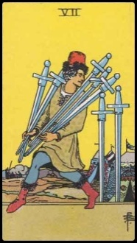 |  |  | 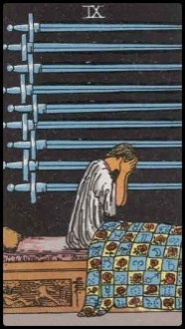
Minor Arcana |  | EIGHT OF SWORDS | Minor Arcana |  |  | TEN OF SWORDS
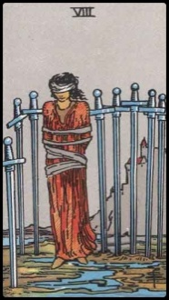 |  |  | 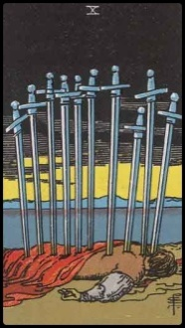

Keyword(s): | Haunted by Loss; Unduly Blaming the Self |  |  | Keyword(s): | Impulsive; Ulterior Motives; Fleeing from Misdeeds
Nine of Swords  Haunted by a loss of a loved one or loss of person who meant a lot to the Seeker. You blame yourself for the loss. You think the loss was your fault that you could have prevented it somehow, but the fact is you could not have. It was beyond your control. It was a loss that would have occurred anyway. It simply had to happen for reasons that Seeker perhaps cannot perceive right now.  Reversed Meaning. Seeker is now in a healing stage. Good news of a loved one. Haunting pain is waning. If Seeker is in a marriage, card in reverse could be hint that Seeker is contemplating infidelity. Cards urge faithfulness. |  |  |  | Seven of Swords  Could indicate someone who flees from the norms of his or her time; someone who feels the need to do things his or her own way. Card could also indicate that Seeker is fleeing from something he or she has done that he or she is not proud of. Could also indicate that someone is spying with ulterior motives. Betrayal. Deception. Look to neighboring cards to determine what interpretation to apply.  Reversed Meaning. If contemplating something unethical, card reversed indicates that Seeker will get caught. Could also indicate that whoever took unjustifiably from Seeker will pay the dues and get caught soon enough. Could also indicate that Seeker is trying to deceive self or others into believing all is well, but cards reveal that truth is all is not well. This is also a card about sabotage, whether to oneself or to others.
Keyword(s): | Retaliation; Defeat; Victim of Others' Aggression |  |  | Keyword(s): | Imprisonment; Feeling Bound or Stuck
Ten of Swords  Low point of Seeker’s life. Sudden misfortune. Defeat. Others are acting against Seeker out of jealous, envy, hatred, aggression, or retaliation. There have been retaliatory actions against Seeker, though Seeker staunchly believes that he or she has acted judiciously. Many against you and you feel defeated by them. However, keep hope. There is a bright horizon and some good will come out of all this, like the yellow light in the card’s horizon. Card should call to mind the story of Julius Caesar.  Reversed Meaning. Courage to rise again. Overthrow of the forces against you. Even though others try to defeat you, you will thwart their retaliatory aggressions. Seeker can endure and will persevere. |  |  |  | Eight of Swords  Seeker feels bound or imprisoned. Mental self-imprisonment. Seeker feels stuck in situation, as if there is no way out. However, Seeker merely cannot see the way out. With strength and creativity, Seeker will be released. Take, for instance, the woman depicted in the card. She is blind to her situation. However, she could use the blades of the swords that surround her to cut through her bondage. Could also indicate restriction of justice.  Reversed Meaning. Feel a sense of release. Recent release from a situation that Seeker had felt bound by. Emancipation. Card could also indicate injustice, as woman bound suggests blind justice not prevailing.
Minor Arcana |  | PAGE OF SWORDS | Minor Arcana |  |  | QUEEN OF SWORDS
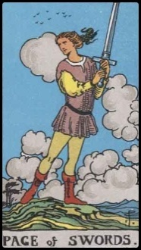 |  |  | 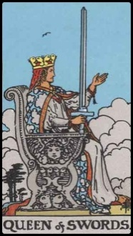
Minor Arcana |  | KNIGHT OF SWORDS | Minor Arcana |  |  | KING OF SWORDS
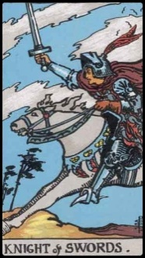 |  |  | 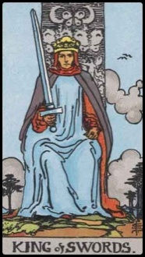

Keyword(s): | Astute; Intensely Perceptive; Strong Character |  |  | Keyword(s): | Aggressive but Graceful; Intellectual
Queen of Swords  Intensely perceptive, quick, and confident adult woman. Perhaps childless. Strong character. She can bear her own sorrows. She does not like to show her weakness to others. Witty. Astute. Fiercely independent.  Reversed Meaning. Tendency to be cruel. Narrow-minded. Prideful. Spiteful. Acting out of pettiness or malice. Holding grudges. Could also indicate a literal woman in Seeker’s life who is having a negative influence on Seeker. Look to neighboring cards and also the location in the spread that the Queen of Swords reversed appears in to determine whether it should take on a literal or figurative meaning. |  |  |  | Page of Swords  Aggressive but graceful young woman. A strong intellectual. Great capacity for learning. Great potential for diplomacy. Likewise, great potential for becoming a fighter. Quick to judgment. Quick to fight. Confrontational. Could be great at war. Too swift to action sometimes. Needs to learn greater self control. In a reading for a young male Seeker asking about love, could indicate the appearance of a young woman with the foregoing qualities.  Reversed Meaning. Fear inhibits action. Seeker is letting other people's judgments, bad advice, and opinions affect his or her perception of the self. Be wary of gossip. Do not care so much about what others think. Could also indicate a young woman in Seeker's life who embodies the qualities of the Page of Swords, but who has a negative impact or influence on Seeker's current situation.
Keyword(s): | Stern; Analytical; Articulate; High Discipline |  |  | Keyword(s): | Domineering; Charging; Great Fighter
King of Swords  Stern demeanor. Intellectual, analytical, articulate male energy. Adult man in the military, or a judge, or a man of extremely high discipline with an analytical mind. Firm in friends; firm in enemies. Overcautious. A wise counselor. Sometimes in his mind he believes he has made a fair judgment, but it is not. He is a man of action.  Reversed Meaning. Ruthless actions. Malice. Ulterior motives. Evil intentions. Not acting with integrity. Destructive, self-serving ambition. Could also indicate a literal man in Seeker’s life who is having a negative influence on Seeker. Look to neighboring cards and also the location in the spread that the King of Swords reversed appears in to determine whether it should take on a literal or figurative meaning. |  |  |  | Knight of Swords  Strong, brave, domineering young man. If in a reading, this young man is charging fast into Seeker’s life. This is a man who has the potential to become a great warrior, a fighter in life. Headstrong. Scatters away threats and competition with intimidation tactics. In a reading for a young female Seeker asking about love, could indicate the appearance of a young man with the foregoing qualities. Someone who likes to dominate.  Reversed Meaning. Warpath. Hostility. Clever at deceit. Wrathful. Engaging in aggressive pursuits out of anger. Reconsider aggressions. Seeker is following the "shoot first, ask questions later" mantra. Not good. Take a step back to clear and calm head. Could also indicate a young woman in Seeker's life who embodies the qualities of the Knight of Swords, but who has a negative impact or influence on Seeker's current situation.
Minor Arcana |  | ACE OF PENTACLES | Minor Arcana |  |  | THREE OF PENTACLES
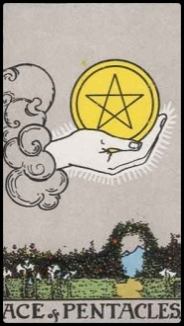 |  |  | 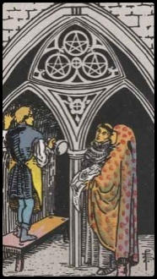
Minor Arcana |  | TWO OF PENTACLES | Minor Arcana |  |  | FOUR OF PENTACLES
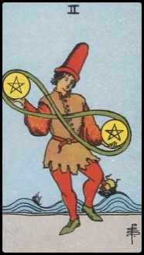 |  |  | 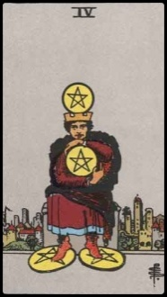

Keyword(s): | Validation in artistic development or craft |  |  | Keyword(s): | Newfound financial prosperity; Auspicious
Three of Pentacles  This card frequently appears in spreads for artists and craftsmen. Skills and abilities will be rewarded. Will gain approval and applause from peers. May indicate membership into a secret fraternity or society. Long overdue recognition is coming.  Reversed Meaning. Mediocrity in workmanship. Mediocrity generally. Card reversed could also indicate difficulties with friends or social circle if Seeker is still in school and difficulties with coworkers if Seeker is working. Conflicts with boss or superiors; conflicts with Seeker's own mentor. Not taking great enough care with one's workmanship; irresponsibility. |  |  |  | Ace of Pentacles  Financial gain to come. New venture in finance or beginning of financial prosperity. Good things of life are to come. You’re headed for an auspicious and comfortable life. Seeker possesses great power for achieving on the material side of life. Will secure money and material possessions.  Reversed Meaning. May experience material gain, but it won’t bring Seeker any happiness. Newfound prosperity but it does not satisfy or fulfill. Disappointment. Disillusionment. False sense of security. There may be misrepresentations made to Seeker about money or investments. Be careful.
Keyword(s): | Miserly; Actually fortunate, but feel impoverished |  |  | Keyword(s): | Multi-tasking; Harmonizing multiple responsibilities
Four of Pentacles  Miser. Seeker has fortune and prosperity and yet is impoverished. Your own material comfort is your obstacle. It is holding you back from happiness. Detach from earthly power and money. Be more generous and open. While Seeker possesses an excellent gift for money management, Seeker is also very miserly and too frugal. The miserliness is causing emptiness. Seeker is not happy in spite of the material wealth he or she has.  Reversed Meaning. You may lose some money or material possessions. Business obstacles. Personal recession. Save, save, save right now. Be cautious and prudence. Be conservative with your expenses. |  |  |  | Two of Pentacles  Great at juggling and harmonizing multiple responsibilities at once. Seemingly infinite potential for handling multiple businesses or multiple venture projects at the same time and succeeding at it all. Seeker can handle tough decisions with grace. Sometimes new projects have a hard time staying afloat due to difficulty in maintaining momentum. Seeker is juggling several pretty good prospects.  Reversed Meaning. Difficulty keeping up with everything that Seeker has on hand. Trying to do too much at once. Seeker must focus and concentrate. Do not try to do everything all at once. Card in reverse could also indicate that Seeker is being led astray by others; others are leading Seeker to foolish action that will cause instability to Seeker's finances.
Minor Arcana |  | FIVE OF PENTACLES | Minor Arcana |  |  | SEVEN OF PENTACLES
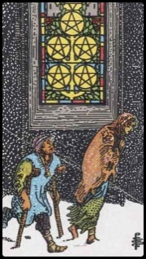 |  |  | 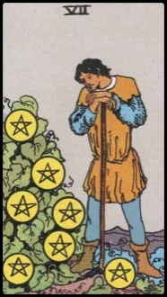
Minor Arcana |  | SIX OF PENTACLES | Minor Arcana |  |  | EIGHT OF PENTACLES
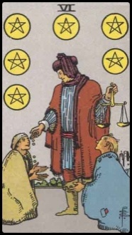 |  |  | 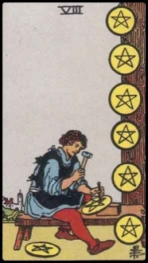

Keyword(s): | Promotion; Hard Work Paying Off |  |  | Keyword(s): | Destitution; Poor Health; Loss of Sense of Home
Seven of Pentacles  Seeker has worked hard and the fruits of his or her labor are now showing. Seeker is financially responsible and has been good with savings. However, for some reason or another, Seeker is hesitating before reaping and enjoying the fruits of that labor. This is a card about investments and return. If Seeker is an artist, then is reevaluating work done so far; Seeker’s heart is in his or her artwork.  Reversed Meaning. Anxiety about whether hard work will bear fruit. Seeker’s heart is invested wholly in this work and thus whether fruition will occur is of high importance to the Seeker. Another reading of this card reversed is that Seeker's head is buried in the sand and is neglecting to confront his or her financial situation. Card is a warning to pay attention to finances better. Could mean that finances are not in order and Seeker must be more wary of own financial stability. |  |  |  | Five of Pentacles  Seeker must be more cautious with his or her health. Take care of your body. Chance of illness. Destitution. Loss of a sense of home. Depression caused by ill health. Poverty, whether poverty in literal finances or poverty in health and spirit. Winter season of current situation. However, take heart that that just means that spring is coming.  Reversed Meaning. Revival. Rebound. Recovery period. Rehabilitation. There was loss in business or profession. It is now time for rebounding. Seeker must use greater efforts to bring recovery to business or profession. Low point in finances.
Keyword(s): | Aspiration; Apprenticing in art or craft |  |  | Keyword(s): | Charity; Generosity; Social Justice; Benevolence
Eight of Pentacles  Someone studying in the arts. Still an apprentice. This is a card about aspirations. Great attention to detail. Methodical in performance in craft. Seeker shows great promise in becoming a highly skilled artisan. Diligence. Hard work. Seeker is on the right track.  Reversed Meaning. Seeker is not working hard enough. Seeker is wasting his or her talents. There is a lot of artistic talent in Seeker, but it is being wasted or not utilized to the fullest. |  |  |  | Six of Pentacles  Generosity. Sharing with others. Social justice. Could either indicate that Seeker is the benefactor to others or Seeker is benefiting from the great generosity of others. If Seeker has a chance of benefiting from others’ generosity, Seeker is encouraged to accept it.  Reversed Meaning. Card is about generosity, but Seeker is not appreciating the generosity of others or that has been bestowed upon him or her. Seeker is reminded to be more appreciative.
Minor Arcana |  | NINE OF PENTACLES | Minor Arcana |  |  | PAGE OF PENTACLES
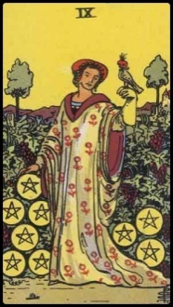 |  |  | 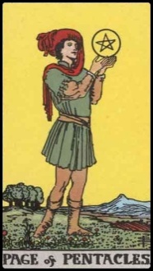
Minor Arcana |  | TEN OF PENTACLES | Minor Arcana |  |  | KNIGHT OF PENTACLES
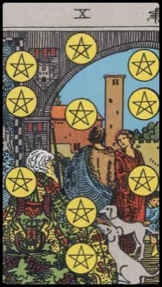 |  |  | 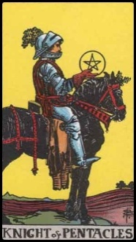

Keyword(s): | Practical; Making a Difference; Scholarship |  |  | Keyword(s): | Prosperity; Material Well-Being; Solitary Enjoyment
Page of Pentacles  Making a difference. This is someone with great respect for learning and scholarship. Perseverance. Born into a good family. Material things and possessions. In a reading for a young male Seeker asking about love, could indicate the appearance of a young woman with the foregoing qualities.  Reversed Meaning. Excess. Wasteful. Love of luxury. Overly materialistic. Not responsible with money. Could also indicate a young woman in Seeker's life who embodies the qualities of the Page of Pentacles, but who has a negative impact or influence on Seeker's current situation. |  |  |  | Nine of Pentacles  Material well-being. Solitary enjoyment of the good things in life. Perhaps Seeker is an accomplished woman who is living alone. Card is about refinement and enjoying easy comfort, but doing so as a single. That is because Seeker is mistrusting of new acquaintances. Could also indicate an inheritance. Wealth and comfort.  Reversed Meaning. There is so much in your life to enjoy, but you are not happy because you feel alone. You’re either single or lonely.
Keyword(s): | Methodical; Rational; Trustworthy; Reliable |  |  | Keyword(s): | Stable, financially secure family life
Knight of Pentacles  Methodical, rational man. Trustworthy, reliable, but perhaps not very imaginative. Conventional. May have a heavy, dull, or materialistic outlook. Kind to animals. Loves nature. Will be financially stable. Will always take care of his loved ones. In a reading for a young female Seeker asking about love, could indicate the appearance of a young man with the foregoing qualities.  Reversed Meaning. Money affairs are at a standstill. Timidity. Could also indicate a young woman in Seeker's life who embodies the qualities of the Knight of Pentacles, but who has a negative impact or influence on Seeker's current situation. |  |  |  | Ten of Pentacles  Stable family. Financial security. Will gain long-lasting wealth and prosperity. Pinnacle of success. This card typically appears in spreads for Seekers who are from a thriving family business or come from a family of wealth or financial stability.  Reversed Meaning. Some strife in a family that is otherwise more accustomed to comfort and stability. Could indicate that a family that once enjoyed material blessings is now falling apart or in flux due to new financial issues. Another reading of the card reversed is that a family that is highly capable with money transactions or a family business, but there is no sense of fulfillment. The family is not enjoying one another’s company. There is detachment or coldness in the home. Home life is not fulfilling.
Minor Arcana |  | QUEEN OF PENTACLES | Minor Arcana |  |  | KING OF PENTACLES
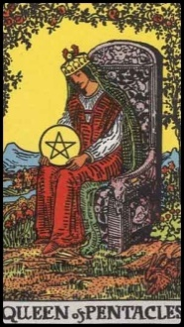 |  |  | 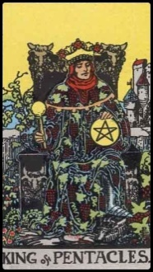
Print odd pages (with tarot card images) on front side of paper.
Reload into printer according to printer's specs to print back side.

Keyword(s): | Chief of Industry; Powerful; Reliable; Self-Control | Keyword(s): | Charitable; Resourceful; Good at Business
King of Pentacles  Chief of industry. A mature man of exceptional self control. Reliable, steady, enterprising male energy. A man in finance, banking, real estate. Reliable married man with children. Great financial gifts; accomplished with finances. He is of great help to the Seeker or potentially very helpful. Could also indicate materialism or dwelling too much on the value of material things, overlooking the spiritual. On the negative side, this person is susceptible to bribery and temptations.  Reversed Meaning. Corruption. Prone to corruption. Bribery. Short-sighted. Obtuse. Sophomoric. Metal laziness. Desires wealth and possessions, but is not even willing to work hard enough to attain that wealth and those possessions. Could indicate unproductive financial endeavors. Card reversed could also indicate an authoritarian male figure in Seeker's life who Seeker is financially dependent on, such as a father, a boss, an older male, etc., but Seeker has a terse or negative relationship with this figure. Could indicate negative influences of a man that fits the profile of the King of Pentacles. |  | Queen of Pentacles  Resourceful, intelligent, thoughtful, creative woman. Rich and charitable. Great at business. Has a lot of material possessions or very interested in material possessions. Pride in her beauty, wealth, fortune, materials, friends, network, etc. Tendency to be vain.  Reversed Meaning. Lacking creative ability. Overdependence on others. Dependence. Could also indicate the negative influence of a woman who fits the profile of the Queen of Pentacles.
After printing odd pages (with tarot card images), reload printer with printed pages so that
even pages (with card meanings) will print on back side of paper.
Flash cards will come out double-sided. Cut into quarters.

